ITEM NO.: 9348 - RITZ (RE) | ASSEMBLY INSTRUCTIONS
 | Carefully unpack all parts before attempting to assemble.
- Connect the backrest (A) with the seat (B) by fitting the hooks on the backrest into the corresponding hook on the seat, as highlighted in the picture.
- Assembly finished.

 | PARTS LIST
 | A - Backrest | 1
 | B - Seat | 1

ITEM NO.: 9348 – RITZ (S2) | ASSEMBLY INSTRUCTIONS
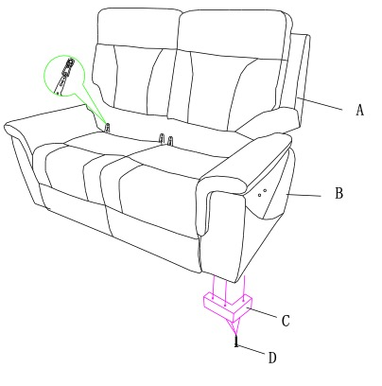 | Carefully unpack all parts before attempting to assemble.
- Using screws (D), fix the feet (C) to their corresponding position on the base of the sofa. Make sure they are facing the right way. Tighten all screws well.
- Connect the backrests (A) with the seat (B) by fitting the hooks on the backrest into the corresponding hooks on the seat, as highlighted in the picture.
- Assembly finished.
 | PARTS LIST
 | A - Backrest | 2
 | B - Seat | 1
 | C - Wooden feet | 4
 | D - Screw | 12

ITEM NO.: 9348 - RITZ (S2R2E) | ASSEMBLY INSTRUCTIONS
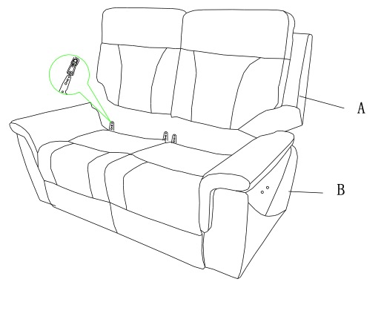 | Carefully unpack all parts before attempting to assemble.
- Connect the backrest (A) with the seat (B) by fitting the hooks on the backrest into the corresponding hooks on the seat, as highlighted in the picture.
- Repeat for the other backrest.
- Assembly finished.

 | PARTS LIST
 | A - Backrest | 2
 | B - Seat | 1

ITEM NO.: 9348 – RITZ (S3) | ASSEMBLY INSTRUCTIONS
 | Carefully unpack all parts before attempting to assemble.
- Using screws (D), fix the feet (C) to their corresponding position on the base of the sofa. Make sure they are facing the right way. Tighten all screws well.
- Connect the backrests (A) with the seat (B) by fitting the hooks on the backrest into the corresponding hooks on the seat, as highlighted in the picture.
- Assembly finished.
 | PARTS LIST
 | A - Backrest | 3
 | B - Seat | 1
 | C - Wooden feet | 4
 | D - Screw | 12

ITEM NO.: 9348 – RITZ (S3R2E) | ASSEMBLY INSTRUCTIONS
 | Carefully unpack all parts before attempting to assemble.
- Connect the backrest (A) with the seat (B) by fitting the hooks on the backrest into the corresponding hooks on the seat, as highlighted in the picture.
- Repeat for the other backrests.
- Assembly finished.

 | PARTS LIST
 | A - Backrest | 3
 | B - Seat | 1

