ITEM NO.: 9343 - RIVIERA | ASSEMBLY INSTRUCTIONS
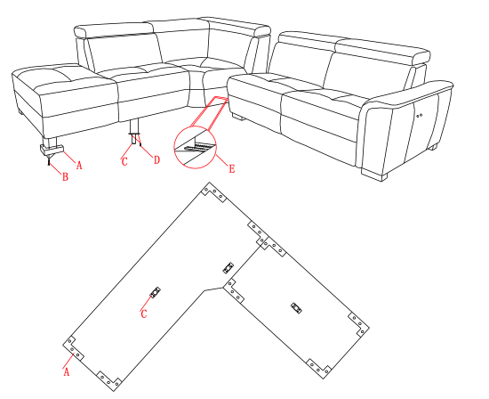 | Carefully unpack all parts before attempting to assemble.
- Fix the feet (A) to their corresponding place on the base of the sofa, using screws (B). Make sure the feet are facing the right way. Tighten all screws well.
- Fix the two middle feet (C) to the corresponding place on the base of the sofa, using screws (D).
- Bring the two pieces of the sofa together and connect the two parts of the K/D crocodile clip (E).
- Assembly finished.

 | PART LIST
 | ITEM | QTY
 | A - Feet | 8
 | B - Screws | 12
 | C - Middle feet | 2
 | D - Screw | 8
 | E – KD Crocodile clip | 1

